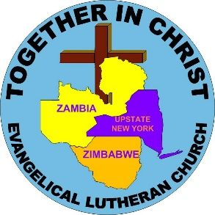
Companion Synod Sunday
May 20, 2018

The Upstate NY Synod is in a Companion Synod relationship with two international Lutheran bodies:
The Evangelical Lutheran Church in Zimbabwe (ELCZ)
The Evangelical Lutheran Church in Zambia (ELCZa)
Answers to FAQs
- All synods within the ELCA have one or more international partners.

- Relationships focus on accompaniment or walking together.

- Covenants to pray for each other and support each other in ministry are signed every five years by residing bishops.

- Some congregations have a twin congregation in Zimbabwe with whom they communicate.

- Pastors and lay people participate in exchanges between the UNYS and Zimbabwe.

For more information about our Companion Synod relationship, contact Beth Walker, UNYS Global Mission Chair, at rbowsend@rochester.rr.com
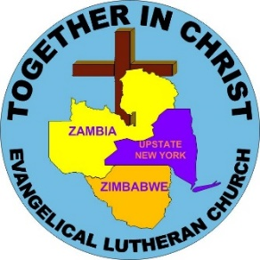
Companion Synod Sunday
May 20, 2018

The Upstate NY Synod is in a Companion Synod relationship with two international Lutheran bodies:
The Evangelical Lutheran Church in Zimbabwe (ELCZ)
The Evangelical Lutheran Church in Zambia (ELCZa)
Answers to FAQs
- All synods within the ELCA have one or more international partners.

- Relationships focus on accompaniment or walking together.

- Covenants to pray for each other and support each other in ministry are signed every five years by residing bishops.

- Some congregations have a twin congregation in Zimbabwe with whom they communicate.

- Pastors and lay people participate in exchanges between the UNYS and Zimbabwe.

For more information about our Companion Synod relationship, contact Beth Walker, UNYS Global Mission Chair, at rbowsend@rochester.rr.com
More Information!

Zimbabwe (ELCZ)

- Located just north of South Africa
- Vision - “To be a spiritually vibrant, self-sustaining and self-propagating church that preaches reconciliation of all human beings to God in Jesus Christ.”

- Three Dioceses – Eastern, Central, Western
- Three bishops with rotating responsibility as head bishop (current head bishop is Rev. C. Faindi)

- Sunday School, Youth, Luther League Seniors’ Fellowship, Women and Men’s Fellowships

- NY Congregation to Parish twinnings
- Pastoral and lay exchanges
- www.elcz.co.zw

Zambia (ELCZa)
- Located north of Zimbabwe and Mozambique
- Smaller church body with Senior Pastor instead of a bishop (current senior pastor is Pastor A. Chana)

- Current focus on building church structures to allow year-round shelter for worship

- UNYS Partnerships: Hope for the Heart Outreach Center Nursery School, Pig and rice farming, Kindles for Pastors.

More Information!

Zimbabwe (ELCZ)

- Located just north of South Africa
- Vision - “To be a spiritually vibrant, self-sustaining and self-propagating church that preaches reconciliation of all human beings to God in Jesus Christ.”

- Three Dioceses – Eastern, Central, Western
- Three bishops with rotating responsibility as head bishop (current head bishop is Rev. C. Faindi)

- Sunday School, Youth, Luther League Seniors’ Fellowship, Women and Men’s Fellowships

- NY Congregation to Parish twinnings
- Pastoral and lay exchanges
- www.elcz.co.zw

Zambia (ELCZa)
- Located north of Zimbabwe and Mozambique
- Smaller church body with Senior Pastor instead of a bishop (current senior pastor is Pastor A. Chana)

- Current focus on building church structures to allow year-round shelter for worship

- UNYS Partnerships: Hope for the Heart Outreach Center Nursery School, Pig and rice farming, Kindles for Pastors.

